# Quinte Financial Technologies | FinTech Solutions

**Assignment on**

**HELOCs AND CREDIT CARDS**

**Under Supervision of:**

**Mr. Mohammad Mozammil**

**Submitted On:**

**28th June, 2024**

**Submitted By:**

**Archita Gupta**

Table of Contents

Home Equity Lines Of Credit 3

Credit Card 8

# 

# Home Equity Lines Of Credit

A Home Equity Line of Credit (HELOC) is a type of loan that allows homeowners to borrow against the equity in their homes. It functions similarly to a credit card, providing a revolving line of credit that homeowners can draw from as needed.

**Key Features:**

1. **Revolving Credit Line**:
   * Borrowers can draw funds up to a predetermined limit.
   * The line of credit replenishes as you pay down the principal, similar to a credit card.
2. **Draw Period and Repayment Period**:
   * **Draw Period**: Typically lasts 5-10 years, during which borrowers can draw from the credit line and are often only required to make interest payments.
   * **Repayment Period**: Follows the draw period, lasting 10-20 years, during which the borrower must repay both principal and interest.
3. **Variable Interest Rates**:
   * HELOCs usually have variable interest rates that can change over time based on market conditions.
   * Some lenders offer fixed-rate options for a portion of the HELOC.
4. **Interest Only Payments**:
   * During the draw period, many HELOCs require interest-only payments, though paying down principal is also possible.
5. **Secured Loan**:
   * The loan is secured by the borrower’s home, making it less risky for lenders and often resulting in lower interest rates compared to unsecured loans.

**Types of HELOCs:**

1. Traditional HELOC: Standard line of credit with variable interest rates.
2. Fixed-Rate HELOC: Offers the option to lock in a portion of the borrowed amount at a fixed rate.
3. Interest-Only HELOC: Allows interest-only payments during the draw period.
4. HELOC-Home Equity Loan Hybrid: Combines features of both a HELOC and a home equity loan.

**Difference between Home Equity Loans and HELOCs:**

|  |  |  |
| --- | --- | --- |
|  | **Home Equity Loan** | **HELOC** |
| **Disbursement** | Lump-sum amount | Revolving credit line for a preapproved amount; contract may require a minimum draw at closing |
| **Repayment** | Fixed monthly payments | Typically interest-only payments during the draw period, followed by full monthly payments |
| **Interest Rates** | Usually fixed | Generally adjustable, though banks may cap your rates or offer a fixed rate for a specific period of time |
| **Points** | Lenders may charge upfront points that lower your interest rate | Does not use points |
| **Closing Costs** | Similar to a first mortgage: typically 2% to 5% of the loan amount | Closing costs (if any) tend to be smaller than those on one-time loans |
| **Pros** | Predictable repayment costs | Flexibility to draw on credit line whenever you need it; no interest payments on money you don't take out |
| **Cons** | Usually higher interest than HELOCs; lack of flexibility | Some borrowers may be tempted to use credit for nonessential purchases |
| **Best For** | One-time expenses where you know exactly how much you need | Situations where you need access to funds at different times |

**Data Points:**

**Market Size and Growth**

1. **Total HELOC Balances**: As of Q4 2023, the total HELOC balances in the United States stood at approximately $340 billion.
2. **Year-over-Year Growth**: HELOC originations increased by about 30% from 2022 to 2023.
3. **Market Penetration**: Approximately 3% of U.S. homeowners had an active HELOC.

**Interest Rates**

1. **Average HELOC Rate**: As of June 26, 2024, the average HELOC rate was around 9.1%.
2. **Rate Range**: HELOC rates typically ranged from 6% to 12%, depending on the borrower's creditworthiness and the lender.
3. **Spread Above Prime**: Most HELOCs were priced at 0.5% to 2% above the prime rate.

**Borrower Demographics**

1. **Average Credit Score**: The mean credit score for HELOC borrowers was 762.
2. **Average Income**: The median household income for HELOC borrowers was $125,000.

**Purpose of Borrowing:**

**Default Rates**

1. **Overall Default Rate**: The 90+ day delinquency rate for HELOCs was approximately 0.7%.
2. **Foreclosure Rate**: The foreclosure rate on properties with HELOCs was about 0.3%.

**Lender Information**

1. **Market Share**: The top 5 HELOC lenders accounted for approximately 35% of all HELOC originations.
2. **Average Approval Time**: The average time from application to approval was 14 days.
3. **Digital Adoption**: About 60% of HELOC applications were initiated online.

**Advantages and Disadvantages:**

|  |  |
| --- | --- |
| **Pros** | **Cons** |
| * Flexible Access to Funds * Interest-Only Payments * Lower Interest Rates * Tax Deductible Interest | * Variable Interest Rates * Risk of Foreclosure * Potential for Over-Borrowing * Equity Reduction |

**Interest rates for three types of home equity borrowing options:**

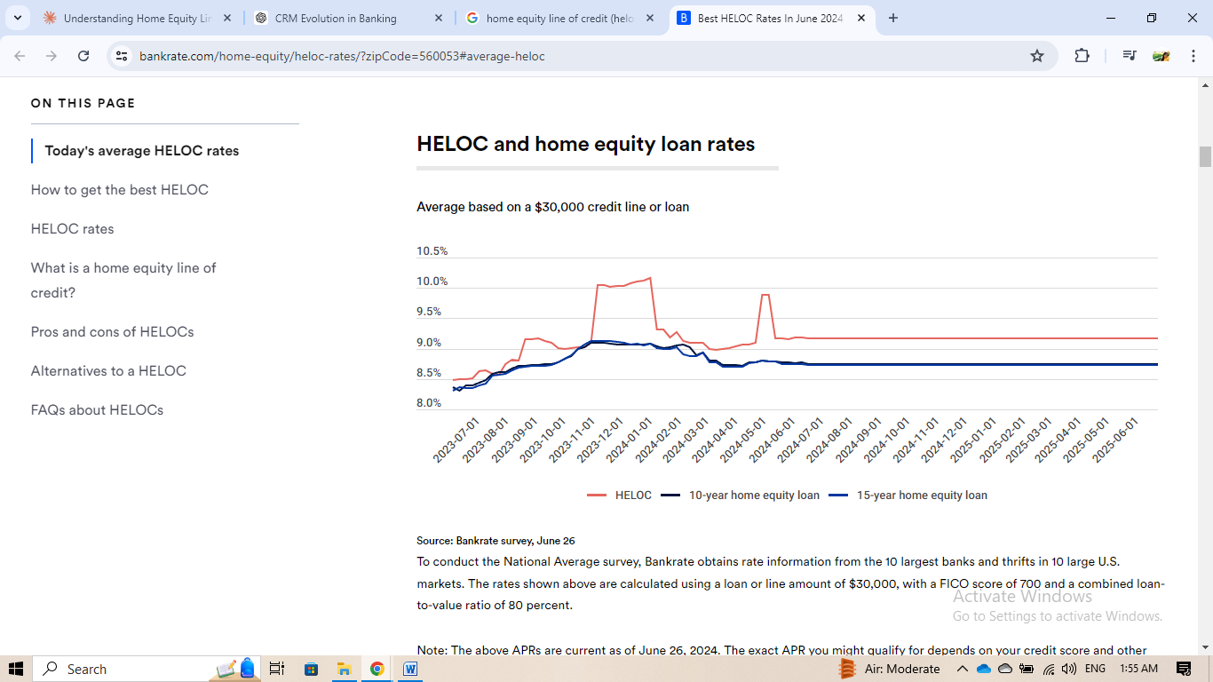

This graph compares the interest rates for three types of home equity borrowing options over time: Home Equity Lines of Credit (HELOCs), 10-year home equity loans, and 15-year home equity loans. The rates are based on an average $30,000 credit line or loan. Key points:

1. Volatility: HELOCs (shown in red) demonstrate the most volatility in interest rates, with several noticeable spikes and dips over the period.
2. Stability of fixed-rate options: Both the 10-year (dark blue) and 15-year (light blue) home equity loans show more stable rates over time, with gradual changes rather than sharp fluctuations.
3. Recent trends: Towards the end of the period shown, all three options seem to stabilize, with HELOCs settling slightly higher than the fixed-rate loans.
4. Rate comparison: For most of the period, HELOCs have higher interest rates than the fixed-rate options, though this gap narrows towards the end.
5. Long-term vs. short-term loans: The 15-year home equity loan generally maintains the lowest interest rate throughout the period, followed closely by the 10-year option.
6. Range of rates: The interest rates for all products generally fall between 8.5% and 10.5% for most of the period shown.
7. Market responsiveness: The HELOC rates appear more responsive to market conditions, likely due to their variable rate nature, while the fixed-rate loans show more inertia.

**Best home equity line of credit (HELOC) rates in June 2024:**

|  |  |  |  |
| --- | --- | --- | --- |
| **LOAN TYPE** | **CREDIT LINE AMOUNT** | **TERM PERIOD** | **CURRENT APR** |
| Comerica Bank | $10,000–$500,000 | 30 years | 6.49% |
| Bethpage Federal Credit Union | Up to $500,000 | 10-year draw, 20-year repay | 6.99% |
| Bank of America | $15,000–$1 million | 10-year draw, 20-year repay | 7.49% |
| Third Federal Savings | $10,000–$200,000 | 30 years | 7.49% |
| BMO | $25,000-$150,000 | 10-year draw/ 20-year repay for variable-rate HELOC; 5-20 year repay for fixed-rate HELOC | 6.99% (fixed) / 8.24% (variable) |
| TD Bank | Starting at $25,000 | Not Specified | 8.24% |
| Guaranteed Rate | $20,000–$400,000 | Up to 30 years | 9.10% |
| Connexus Credit Union | Starting at $5,000 | 15-year draw, 15-year pay | 8.74% |

# Credit Card

A credit card is a financial tool issued by banks or financial institutions that allows cardholders to borrow funds for purchases, with the agreement to pay back the borrowed amount along with any applicable interest and fees. Credit cards offer convenience, security, and various benefits, but they also come with risks and responsibilities.

By law, credit card issuers must offer a grace period of at least 21 days before interest on purchases can begin to accrue.

**Key Features:**

1. **Revolving Credit**: Users can borrow up to a certain limit and carry a balance from month to month.
2. **Grace Period**: Most cards offer an interest-free period if the full balance is paid each month.
3. **Minimum Payments**: Cardholders must make at least a minimum payment each month.
4. **Interest Charges**: If the full balance isn't paid, interest is charged on the remaining amount.
5. **Rewards Programs**: Many cards offer cash back, points, or miles on purchases.
6. **Fees**: May include annual fees, late payment fees, foreign transaction fees, etc.

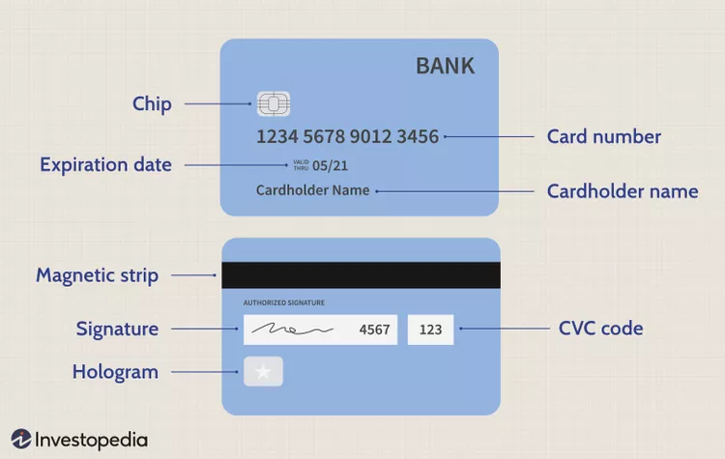

Front of the card:

1. Chip: This is an EMV (Europay, Mastercard, and Visa) chip that provides enhanced security for transactions.
2. Card number: A 16-digit number unique to this card, used to identify the account during transactions.
3. Expiration date: The date after which the card is no longer valid and needs to be replaced.
4. Cardholder name: The name of the person authorized to use the card.
5. Bank: The name of the issuing bank or financial institution (not labeled but typically present).

Back of the card:

1. Magnetic strip: Contains encoded information about the card and account, used for swiping transactions.
2. Signature: A space for the cardholder's signature, which can be used to verify identity during in-person transactions.
3. CVC code: The Card Verification Code (also known as CVV), a 3-digit security code used for online or phone transactions.
4. Hologram: A security feature that helps to prevent counterfeiting (shown as a star symbol in this image).

**Types of Credit Cards:**

1. **Standard Credit Cards**:
   * Basic credit cards with no additional features.
   * Suitable for straightforward spending and credit building.
2. **Rewards Credit Cards**:
   * Offer rewards like cash back, points, or miles for purchases.
   * Categories may include travel, dining, groceries, and more.
3. **Secured Credit Cards**:
   * Require a cash deposit as collateral.
   * Ideal for building or rebuilding credit.
4. **Student Credit Cards**:
   * Designed for college students with limited credit history.
   * Often have lower credit limits and simpler rewards.
5. **Business Credit Cards**:
   * Tailored for business expenses and often offer business-related rewards and benefits.
   * Can help separate personal and business finances.
6. **Balance Transfer Credit Cards**:
   * Offer low or 0% introductory APR on balance transfers.
   * Useful for paying off high-interest debt.
7. **Low-Interest Credit Cards**:
   * Offer lower APRs on purchases.
   * Beneficial for carrying a balance month-to-month.
8. **Travel Credit Cards**:
   * Provide travel-related rewards and benefits, such as miles, travel insurance, and no foreign transaction fees.

**Key Statistics (as of early 2024)**

1. **Number of Cards**: Approximately 1.1 billion credit cards in circulation in the U.S.
2. **Average Number per Person**: The average American has 3.8 (4) credit cards.
3. **Average Credit Card Debt**: $6,365 per cardholder.
4. **Total Credit Card Debt**: U.S. credit card debt surpassed $1 trillion in 2023.
5. **Average APR**: The average credit card APR is around 27.70% (as of June,2024)
6. **Rewards Value**: The average cash back rate is 1.5% to 2%.

**Impact of Economic Conditions**

1. **Interest Rates**: Credit card APRs have risen in response to Federal Reserve rate hikes.
2. **Spending Patterns**: Post-pandemic, there's been an increase in credit card usage for both essential and discretionary spending.
3. **Credit Standards**: Some issuers have tightened approval requirements due to economic uncertainties.

### Average APRs on Accounts Assessed Interest and Average Prime Rate at Year End:

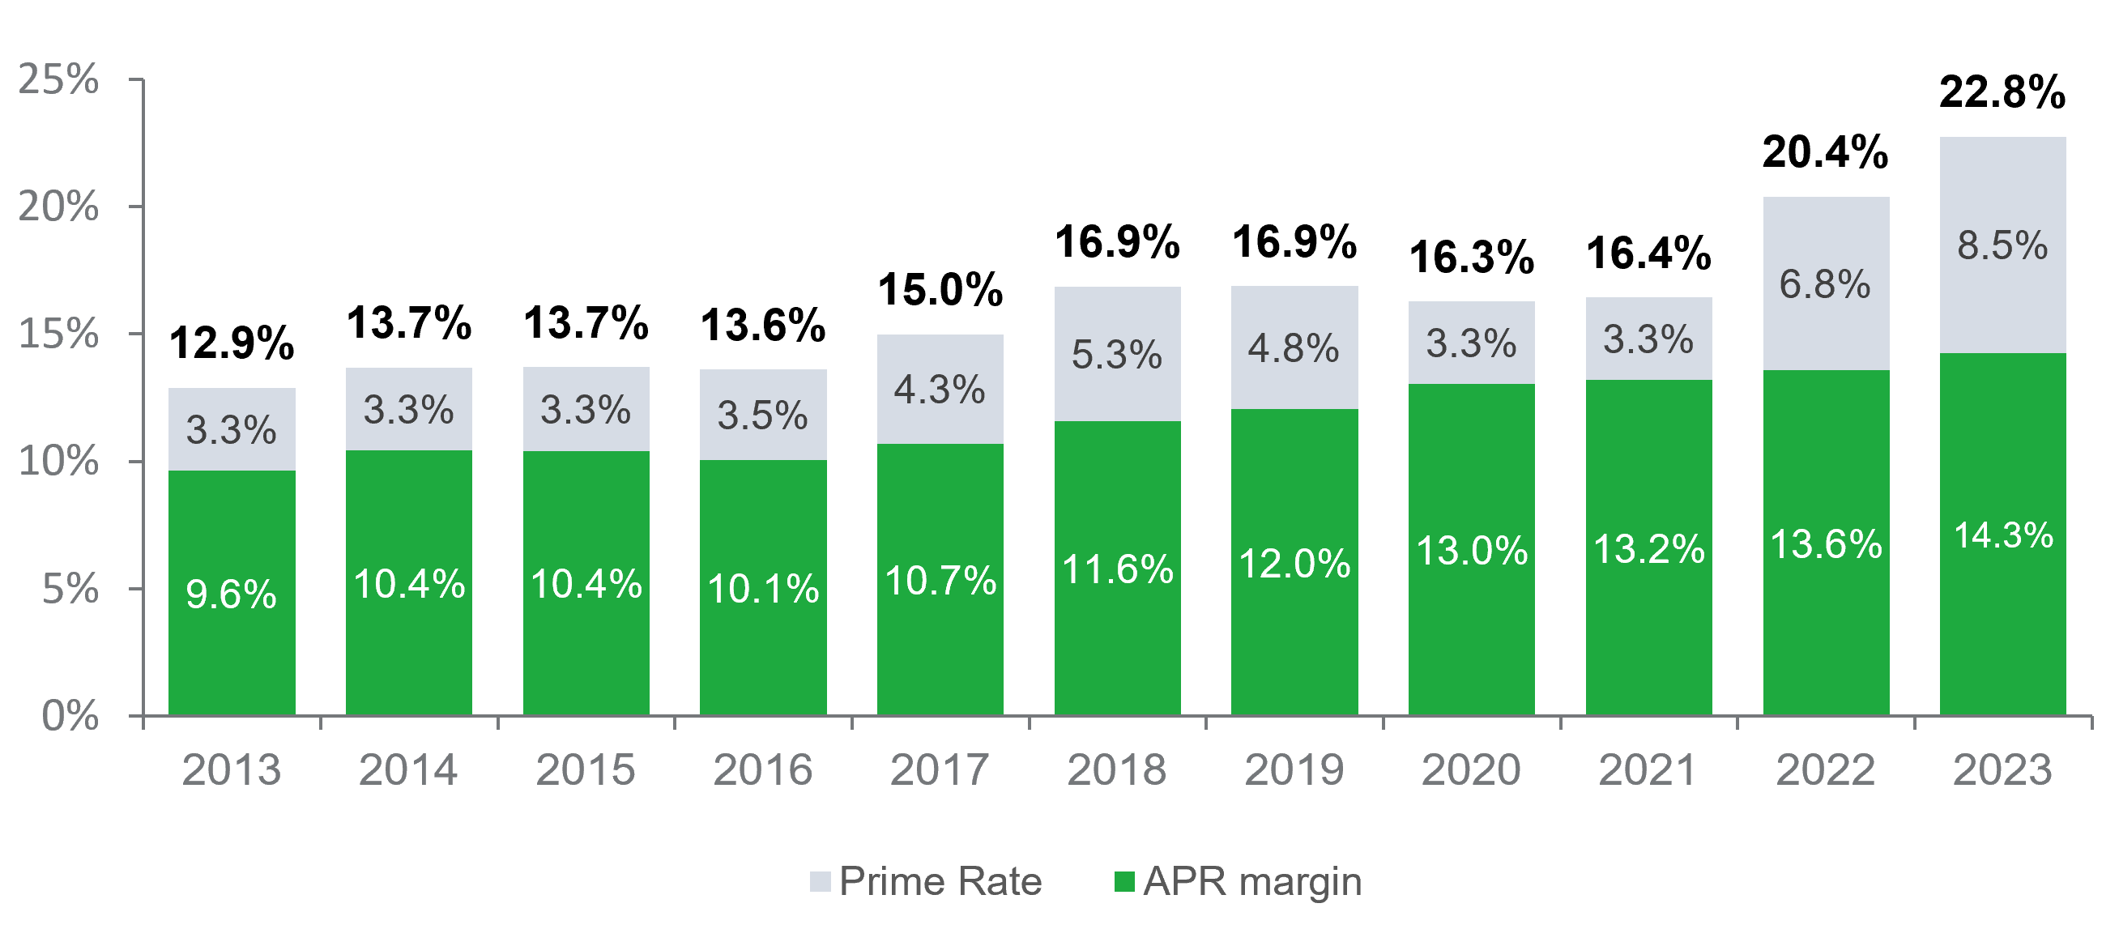The image shows a chart tracking APR margin (green bars) and Prime Rate (gray bars) from 2013 to 2023.

Key observations:

1. Overall trend: Both metrics have generally increased over the 10-year period.
2. APR margin:
   * Started at 9.6% in 2013
   * Steadily increased to 14.3% in 2023
   * Shows consistent year-over-year growth
3. Prime Rate:
   * More volatile than APR margin
   * Remained relatively stable (3.3%-3.5%) from 2013 to 2016
   * Began increasing in 2017, reaching 8.5% in 2023
4. Total percentage (combined APR margin and Prime Rate):
   * Increased from 12.9% in 2013 to 22.8% in 2023 (almost double)
   * The 2023 data was the highest level recorded since the Federal Reserve began collecting this data in 1994.

Possible reasons for these trends:

1. Economic recovery: The steady increase in both metrics may reflect the overall economic recovery following the 2008 financial crisis.
2. Federal Reserve policies: Changes in the Federal Reserve's monetary policy, particularly interest rate hikes, directly impact the Prime Rate.
3. Increased demand for credit: Growing consumer confidence and spending may have allowed lenders to increase their APR margins.
4. Risk management: Banks might be increasing their APR margins to compensate for potential risks in the lending market.
5. Inflation: Rising inflation rates could be contributing to the increase in both the Prime Rate and APR margins.
6. Competitive pressures: The banking industry's competitive landscape may influence how institutions set their APR margins.
7. Regulatory changes: New financial regulations implemented over this period could have impacted how banks price their loans and credit products.

The consistent rise in APR margin suggests that lenders have been able to maintain or increase their profitability on loans, while the more volatile Prime Rate reflects broader economic conditions and monetary policy decisions.

**Best Credit Cards 2024:**

|  |  |  |  |
| --- | --- | --- | --- |
| **Card** | **Best For** | **CreditScore** | **Annual Fee** |
| Capital One Quicksilver Cash Rewards Credit Card | Best Overall, Best Cash Back Credit Card | 670-850 | $0 |
| Chase Sapphire Reserve | Best Travel, Best Rewards Credit Card | 800-850 | $550 |
| United℠ Explorer | Best Airline Credit Card | 670-850 | $0 for the first year, then $95 |
| World of Hyatt Credit Card | Best Hotel Credit Card | 670-850 | $95 |
| Citi Diamond Preferred Credit Card | Best Balance Transfer Credit Card | 670-850 | $0 |
| Bank of America Travel Rewards for Students | Best Student Credit Card | 670-850 | $0 |
| Ink Business Preferred Credit Card | Best Business Credit Card | 670-850 | $95 |
| Blue Cash Preferred Card from American Express | Best Groceries Credit Card | 670-850 | $95 |
| Capital One SavorOne Cash Rewards Credit Card | Best Online Shopping Credit Card | 670-850 | $0 |
| Capital One Platinum Secured | Best Secured Credit Card | 350-850 | $0 |

**Exclusive Credit Cards That Require an Invitation:**

These ultra-exclusive credit cards are designed for the wealthiest individuals and offer unmatched luxury and privileges.

|  |  |  |  |
| --- | --- | --- | --- |
| **Card Name** | **Eligibility** | **Annual Fee** | **Perks** |
| Centurion® Card from American Express | By invitation only, typically extended to high-net-worth individuals who are long-standing American Express cardholders with significant annual spending. | $5,000 with a $10,000 initiation fee | Personal concierge service available 24/7, access to exclusive events and experiences, complimentary elite status with various airlines and hotels, access to private jet services and luxury travel benefits |
| JP Morgan Reserve Card | By invitation only, usually offered to clients with at least $10 million in assets managed by JP Morgan. | $595 | 3x points on travel and dining, access to airport lounges via Priority Pass Select, travel and purchase protection benefits, comprehensive concierge services |
| Dubai First Royale Mastercard | By invitation only, typically reserved for the ultra-wealthy in the UAE and other high-profile individuals globally. | Not publicly disclosed | Unlimited credit limit, personal relationship manager, access to a bespoke lifestyle management program, exclusive access to events and experiences |
| Coutts Silk Charge Card | By invitation only, primarily offered to Coutts banking clients, including members of the British royal family. | Not publicly disclosed | Personalized concierge services, access to exclusive events and experiences, travel and lifestyle benefits, high spending limits and luxury perks |
| Citigroup Chairman American Express Card | By invitation only, generally extended to clients with significant assets under management. | Not publicly disclosed | High reward rates on purchases, access to exclusive events and experiences, personalized concierge services, comprehensive travel benefits and insurance |

Thank You